Travel instruction  Physikzentrum Bad Honnef, Hauptstr. 5, 53604 Bad Honnef  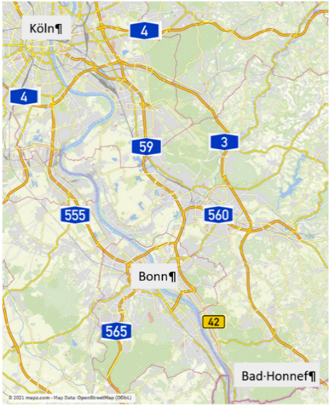  By train: Railway station „Rhöndorf”  By tram: S-Bahn 66, station „Am Spitzenbach”  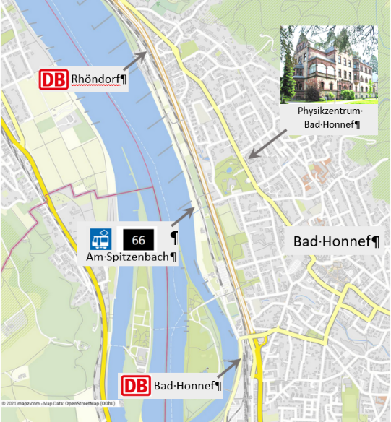 | Organization  Prof. Dr. Arne Lützen  Kekulé Institute of Organic Chemistry  University of Bonn, Tel.: +49 228 737533  Email: arne.luetzen@uni-bonn.de  Prof. Dr. Sigurd Höger  Kekulé Institute of Organic Chemistry  University of Bonn, Tel.: +49 228 736127  Email: hoeger@uni-bonn.de  Prof. Dr. Michael Mastalerz  Institute of Organic Chemistry, Heidelberg University  Tel.: +49 6221 54 6207  Email: michael.mastalerz@oci.uni-heidelberg.de  Organization Office  Ulrike Blank  Kekulé Institute of Organic Chemistry  University of Bonn  Gerhard-Domagk-Str. 1  Tel. +49 228 733495  Fax.: +49 228 735662  Email: KOPO2026@uni-bonn.de  Further information and registration:  https://www.chemie.uni-bonn.de/oc/de/kopo-2026 | 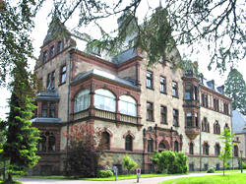  Welcome to the  KOPO 2026  Planar and Non-Planar Pi-Systems  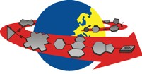  Physikzentrum Bad Honnef  May 10-13, 2026  Program

Book of abstracts:  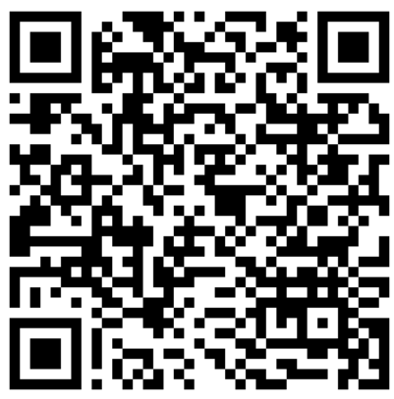  Sunday, May 10, 2026  15:30 - 17:00 Registration & Coffee reception  17:00 Opening: Arne Lützen, Sigurd Höger  17:15 - 18:00 Rudolf-Gompper-Memorial Lecture  Ullrich Scherf  Conjugated Ladder Polymers –  The Post-Polymerization approach  18:00 Time to prepare poster session  18:30 - 20:00 Dinner  20:30 Workshop Mixer | Monday, May 11, 2026  07:30 Breakfast  09:00 Plenary lecture: Marcel Mayor  From «Geländer» Architectures to Mechanosensitivity  10:00 Johannes Teichert  Shining light on neutral homoaromatic hydrocarbons  10:25 Jens Voskuhl  Shrinking Luminophores – What is the limit  10:50 Coffee Break  11:10 Prince Ravat  Through-space coupling in three-dimensional chiral helicene diimides  11:35 Salome Heim  Electronic modulation of optical and chiroptical properties in compact [2.2]paracyclophane-based macrocycles  12:15 Lunch  14:00 Rainer Winter  A single molecule approach to redox and conformationally triggeres conductance switches  14:25 Xingmao Chang  (Supra)molecular multiple spin systems  14:50 Oliver Dumele  Organic spin-state photoswitches  15:15 Coffee Break  16:00 Holger Helten  Boron-doping of porphyrins and expanded rylene dyes: from aromaticity witches to NIR-emissive (radical anions)  16:25 Vincenzo Brancaccio  B,N-Embedded helicenes with narrowband circularly polarized luminescence  16:50 Sanchari Debnath  Planar chiral 1,2:5,6-naphthalene bisimide heterocyclophane for circularly polarized delayed fluorescent  18:00 Dinner  19:00 Poster Session | Tuesday, May 12, 2026  07:30 Breakfast  09:00 Plenary lecture: Milan Kivala  π-Conjugated Polycyclic Scaffolds: From Synthetic Challenges to Functional Materials  10:00 Daniel Baumgarten  Phenothiazine redox mediators to boost photocatalytic hydrogen evolution  10:25 Wojciech Stawski  Nanohoops meet batteries: organic electrode materials based on pi-conjugated macrocycles  10:50 Coffee Break  11:10 Jonas Meringdal  A Rational Guide to Suzuki-Miyaura Coupling  11:35 Lea Hake  Synthesis of oligoarylenes via micellar catalysis  12:00 Liping Ye  Chirality-assisted synthesis of conjugated carbon nanobelts  13:00 Lunch  14:30 Excursion: Visit at Haus der Geschichte (Bonn), dinner at Bundeshäuschen (Oberkassel)  Wednesday, May 13, 2026  07:30 Breakfast  09:00 Plenary lecture: Agniezka Nowak Król  Chiral BN-Containing PAHs: From Design and Synthesis to Function  10:00 Michael Giese  3D-printabale smart materials – how dynamic-covalent bonds make a smart material  10:25 Moritz Schuldt  Towards Planar and Tubular Haeckelites  10:50 Coffee Break  11:10 Jingjiang Zhang  Atomically precise graphene nanoribbons: from topological design to quantum device integration  11:35 Jakob Gabriel  Investigation of Molecular Rods in a Pseudo Inert Environment  12:30 Closing remarks: Arne Lützen, Sigurd Höger  12:30 Lunch

